Ex.No.10 – Use Ghidra to Disassemble and Analyze an Executable
Aim
To use Ghidra to disassemble and analyze an executable file, examine its functions, strings, imported components, and decompiled code, and understand the basic behavior of the analyzed program.
Objectives
- To understand the basic use of Ghidra for executable analysis.
- To examine the structure and components of a Portable Executable (PE) file.
- To identify strings, imported components, and functions using Ghidra.
- To examine the main function using the CodeBrowser and Decompiler.
- To understand the basic workflow used in static malware analysis.
Tools Required
- Ghidra 12.1.4
- Java Development Kit (JDK)
- Windows operating system
- Benign test executable (sample.exe)
Safety Note
A harmless test executable was used for this experiment instead of live malware. The executable was analyzed statically without intentionally executing it.

Procedure
Step 1 – Create a Ghidra Project
A new non-shared Ghidra project named Ex10_Ghidra was created.
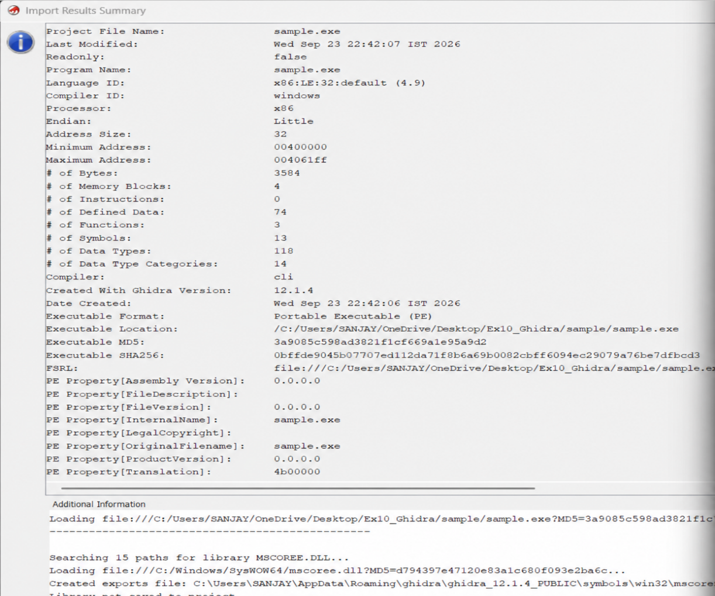

Step 2 – Import the Executable
The sample.exe file was imported into the Ghidra project. Ghidra identified the file as a Portable Executable (PE).
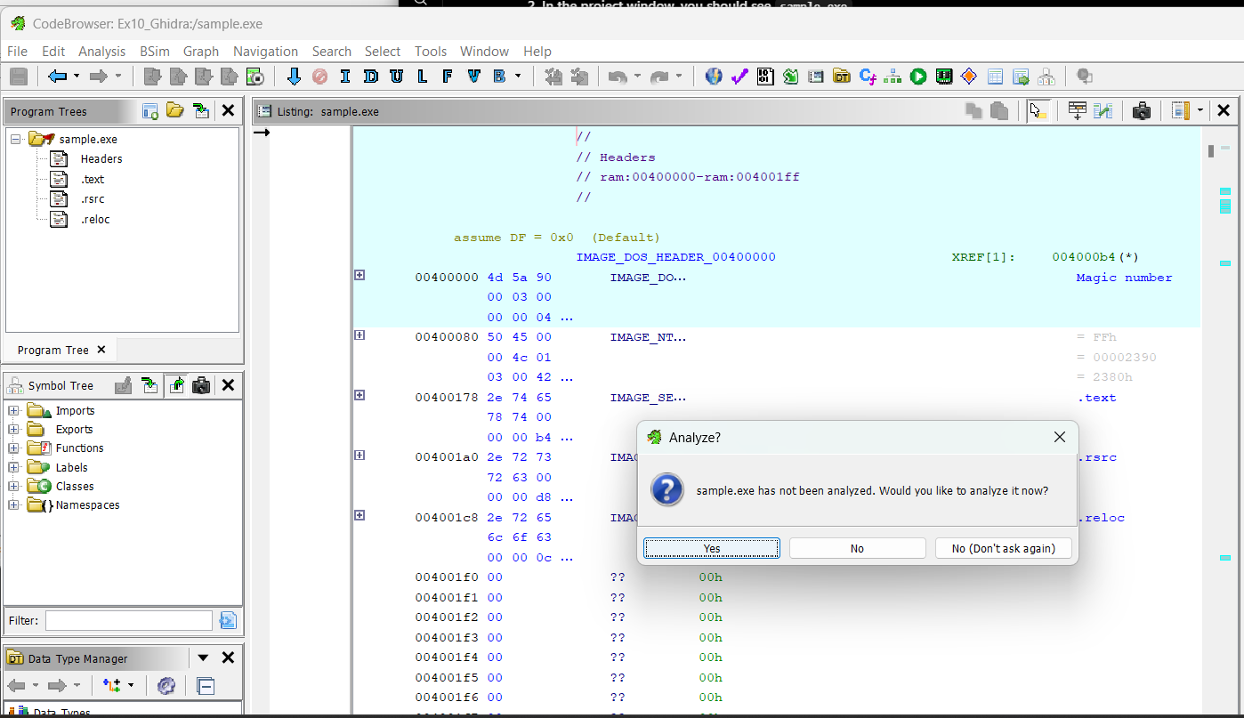

Step 3 – Perform Automatic Analysis
The default Ghidra analysis options were used to analyze the executable.
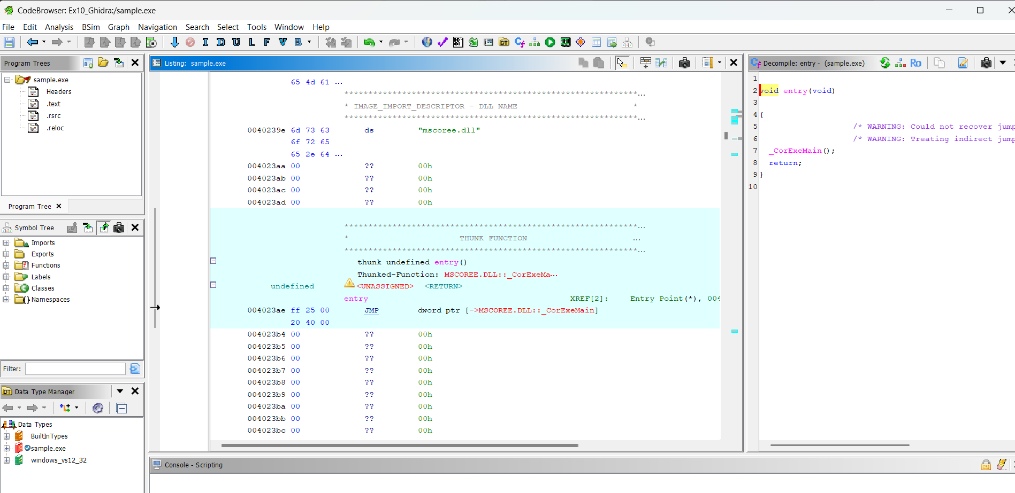

Step 4 – Analyze Strings
The String Search feature was used to identify readable strings in the executable. Ghidra identified 44 strings.
Important strings included:
- Ghidra Malware Analysis Lab Sample
- This is a harmless test program.
- Console
- WriteLine
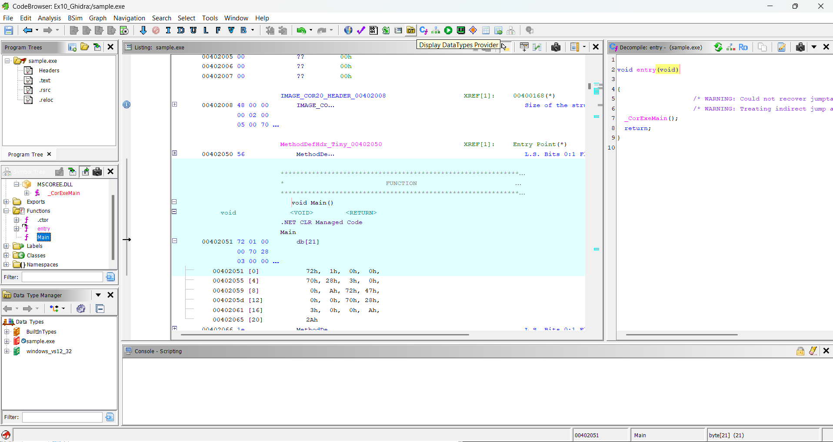

Step 5 – Analyze Imported Components
The Imports section was examined to identify external components used by the executable. The analysis showed MSCORE...DLL and _CorExeMain.
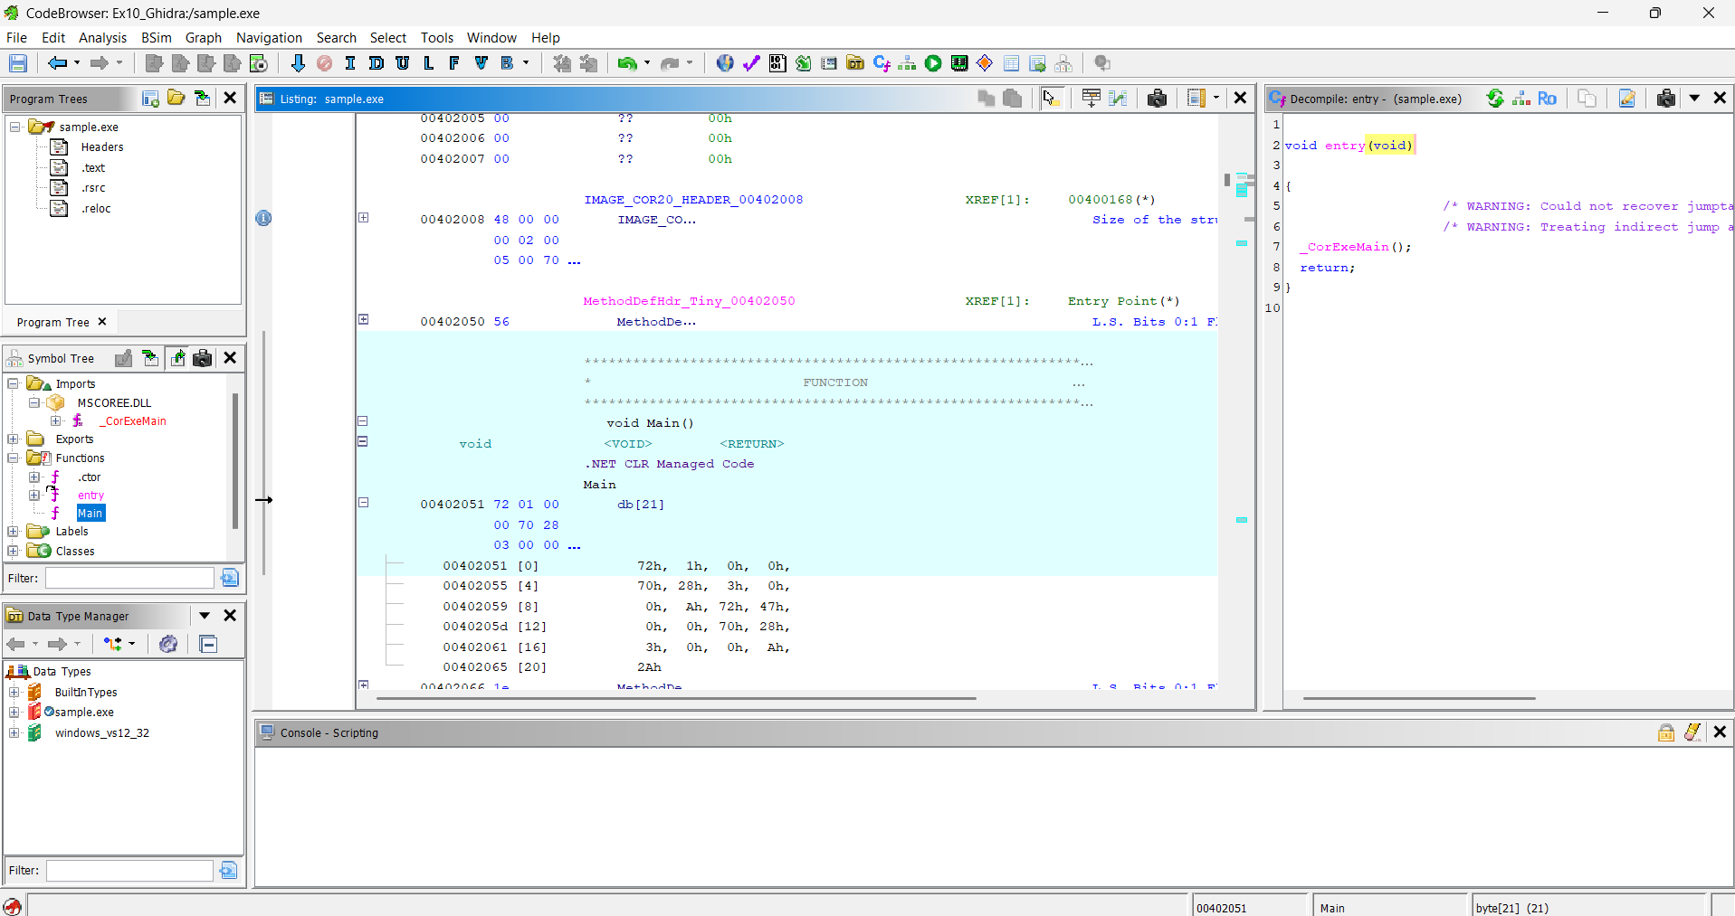

Step 6 – Analyze Functions
The Functions section was examined. Ghidra identified the functions .ctor, entry, and Main.
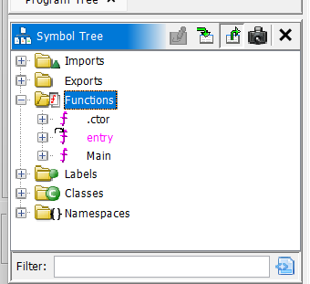

Step 7 – Analyze the Main Function
The Main function was opened in the Ghidra CodeBrowser and examined using the available decompiler view.

Observation
The executable was successfully loaded and analyzed using Ghidra. The file was identified as a Portable Executable (PE) for the x86 architecture. Ghidra identified the .text, .rsrc, and .reloc sections and detected 44 readable strings. The imported runtime component included MSCORE...DLL with _CorExeMain. The Functions window identified .ctor, entry, and Main.
The strings found in the executable indicated that it was a harmless test program created for analysis purposes.

Result
The sample.exe file was successfully imported, disassembled, and analyzed using Ghidra. The executable's strings, imported components, functions, and Main function were examined using the Ghidra CodeBrowser and available decompiler views.

